GIS data types and structure
A geographic information system (GIS) is a computer system that captures, stores, verifies, and displays this data. Integrating GIS data provides a more insightful view of a location, which will allow users to more accurately compare the location of different objects to discover how they relate to each other, as well as make informed decisions on geographic planning.
There are different types of data utilized in GIS mapping. We will discuss the different types of GIS data and how this data is used in various industries and technologies.
GIS Data Types
Spatial Data (The "Where")
Spatial data refers to geographic information that is referenced to a specific location on the Earth's surface.
- Vector Data: Represents discrete features like points (e.g., locations of wells), lines (e.g., roads), and polygons (e.g., boundary of a lake).
- Raster Data: Represents continuous, surface-based information using a grid of pixels (e.g., satellite imagery, digital elevation models)
- Examples: GPS coordinates, CAD files, shapefiles, KML, and GeoJSON.
Non-Spatial Data (The "What")
Non-spatial data, often called attribute data, provides information about the spatial features without defining their location.
- Characteristics: It is often tabular and independent of geometric considerations.
- Examples: A table containing the name of a city, its population, its mayor, and its postal code is non-spatial data, even though it refers to a specific, located point on a map.
There are two different types of GIS data, vector data and raster data. Each type of data has its format.
Vector Data
Vector data is the spatial data most people are familiar with, as it is the format presented in mapping portals such as Open Street Maps and Google Maps. It is also used extensively in computer graphics and computer-aided design (CAD). It consists of points, lines, and polygons.
Structure: Coordinate-based, using vertices (points) to define shapes and locations.
- Point Data – Point Data typically represents nonadjacent features or distinct data points. Points are zero-dimensional, so you cannot measure their length or area. Examples of point data would be cities, points of interest, and schools.
- Line Data – Line data is also known as arc data. It represents linear features such as rivers, streets, and trails. Line data has a starting and an ending point, and, since it only has one dimension, it can only be used to measure length.
To distinguish arc features from each other, some lines may be solid while others are dashed, and different colours or line thicknesses may be used. For example, a road may be a solid black line, while a river is a dashed blue line.
- Polygon Data – Polygons typically represent areas such as cities, lakes, or forests. Unlike point and line data, polygons are two-dimensional and can measure the perimeter or area of a geographic feature. Colour schemes, patterns or gradation colour schemes could be used to identify polygon features.
Vector images are high-quality representations of an image or a shape. They can be enlarged or reduced with no loss of quality. To create or manipulate a vector image, you must use a program like Adobe Illustrator. A camera cannot capture a vector image.

Raster Data
Raster data, also known as grid data, is made up of pixels, and each pixel has a value. You will typically find raster data on topographic maps, satellite images, and aerial surveys. Raster data is vital for meteorology, disaster management, and industries where analysing risk is essential.
Structure: A matrix of uniformly sized cells arranged in rows and columns.
There are two types of raster data, continuous and discrete.
- Continuous Data – Continuous rasters are cells on the grid that gradually change. Some examples would be an aerial photo, elevation and temperature. Continuous raster surfaces come from a fixed registration point. For instance, in digital elevation models, sea level is used as a registration point. Each cell represents a value that is above or below sea level.
- Discrete Data – Discrete rasters have a specific theme or class, and each pixel is assigned to a specific class. Unlike continuous data, discrete data can only take specific values, not values within a range. For example, in a discrete raster land cover/use map, you can see each thematic class, and where it begins and ends is defined.
Unlike vector data, raster data is not scalable. If it is enlarged too much, it will get pixelated, and if stretched too much, it will become distorted. A digital photo is an example of raster data.
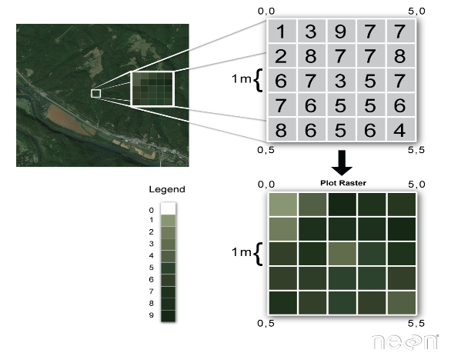
Difference Between Vector Data and Raster Data:
Vector Data | Raster Data
1. It is used to store data having discrete boundaries in Point, Line and Polygon | 1. It consists of cells organised in rows and columns with each cell having one value.
2. It is discrete in nature. | 2. It is continuous in nature.
3. It is complex data | 3. It is simple data
4. Example- Administrative borders, roadways, rivers, location of a house, forest area, fallow land etc. | 4. Example- Temperature, air pressure, elevation, flow and distance etc.
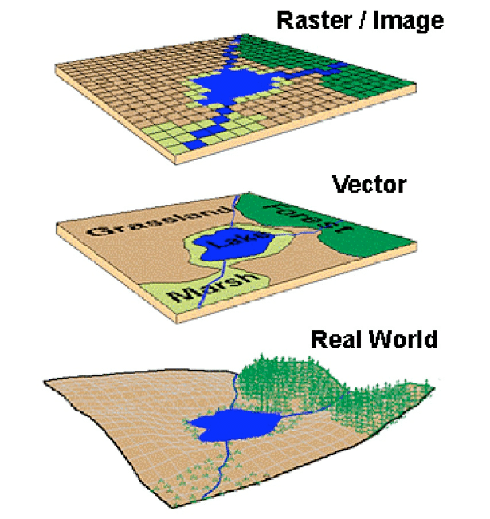

What Is Database Management in GIS?
Database Management in GIS (Geographic Information Systems) refers to the organized handling, storage, and retrieval of spatial data. It plays a crucial role in ensuring geographic data—such as maps, coordinates, and attributes—is structured for effective analysis, visualization, and decision-making.
This process involves managing large datasets, applying data models, maintaining data integrity, and optimizing performance for querying geographic features. In GIS, databases store various types of spatial data (e.g., roads, rivers) and link them with non-spatial attributes (e.g., names, statistics). Effective database management ensures high data quality, easy access, and seamless integration of spatial and non-spatial information.
Why is database management important for GIS?
Database management is essential for GIS (Geographic Information Systems) as it ensures that vast amounts of spatial and non-spatial data are accurately stored, organized, and easily accessible.
This enables GIS professionals to:
- Maintain Data Integrity: Accurate, up-to-date data is critical for reliable geographic analysis, minimizing errors in mapping, environmental studies, or urban planning.
- Enable Efficient Data Retrieval: Well-managed databases provide quick access to spatial data, speeding up decision-making, especially in time-sensitive scenarios like disaster management or real-time traffic monitoring.
- Support Complex Queries and Analysis: GIS systems often handle large datasets requiring complex operations (e.g., finding the nearest water source). Effective database management ensures these queries are processed efficiently.
- Facilitate Collaboration: A centralized, well-maintained GIS database allows teams to access and share data seamlessly, improving collaboration across departments like urban planning, environmental agencies, and public safety.
Ultimately, database management in GIS ensures spatial data is accurate, reliable, and readily available to inform decision-making across various industries.

